I CAN’T BEAR WATCHING SHAKUNTALA DEVI THIS WAY- AN HONEST OPINION.

So much overwhelmed to see that the biopic has returned with a fabulous depiction of an extraordinary Indian known for her exquisite mathematical skills, Mrs. Shakuntala Devi. Bollywood has a bunch of [biopics](https://en.wikipedia.org/wiki/Shakuntala_Devi) upon different persons based on different fields and categories. And somehow the biopic of the person “***Mrs. Shakuntala Devi***” is as unique as always.

It is a proud moment to see an Indian Mathematician on silver screens. This time the character isn’t a male but a woman. Breaking the barriers of patriarchal society and norms, the movie “Shakuntala Devi” is born once again to challenge society. It bounds to leavee us inspiring and knowledgeable at the end of the movie.

Left: Vidya Balan starring as Shakuntala Devi in Shakuntala Devi Movie
Right: Original Shakuntala Devi at Guiness World Record session

*Left: Vidya Balan starring as Shakuntala Devi in Shakuntala Devi Movie  
Right: Original Shakuntala Devi at Guinness World Record session*

**What hits me hard?**

Coming back to the topic of discussion, Amazon Prime released the trailer of the movie “***Shakuntala Devi***”. It is based on a great Indian woman mathematician. She is also known for winning the prestigious Guinness Book of World Records for Mental Mathematics skills. My opinions will be purely honest while reviewing out the trailer. And if point seems displeasing, I welcome you to suggest to me in **the comment section.**

Therefore, my reaction to the trailer of the movie was not an expected one. I mean, I just didn’t like the trailer for some particular reasons. I won’t deny the efforts, the characters, the setting, etc. They were really impressive but there are certain factors that dismayed me a lot regarding the construction of a biopic!

Now straight to the point, the “Shakuntala Devi” trailer seems much like a rom-com movie than a biopic. My research says Shakuntala Devi in real life was a serious lady but with a jolliness. She had a fun going attitude and a smile on her face. I can’t dismiss her joyful nature, but too much jolliness and overreacting depiction can go incorrect. It makes me believe that.

**The real story:**

Shakuntala Devi was an Indian Mathematician, a scholar, an astrologer. She was the winner of the Guinness Book of World records. She was born in Bengaluru, Karnataka, India in the year 1929. Being a prodigy in her early days, she was a lovable daughter, a wife, and a mother. Apart from these positions, she achieved fame-name, “**Human-Computer**”, and becoming a great writer and an astrologer. She passed away in the year 2013 due to heart and kidney compilations.

When other women during the early 90’s still struggled to come out of their homes, Shakuntala Devi challenged society with her mental skills and a supportive father. She traveled across the globe as the westerners invited her out of curiosity. This can somehow make her free of all the rules and regulations, hence, she might have developed her jolly and cheerful attitude which is really a positive factor, but I couldn’t digest the fact that she would be so much overdramatic. A mathematician generally tends to be serious with his/her actions and work, they dive into the depth of numbers, but it is quite not necessary to overdramatize the movie just for the sake of Bollywood trending.

**Other Biopics:**

When compared to the biopics of Hollywood, there are still many aspects of Bollywood which needs to be improved. Had the film been produced and directed by Hollywood, it could have been more systematic as a biopic of a ‘Mathematician’. Since Shakuntala Devi herself was a serious mathematician the Bollywood version film could have been a bit serious. Rather than focusing much on her family life, the depiction of her career and her works and the method to learn mathematics would have inspired millions encouraging them to fall in love with Mathematics. When the trailer begins, the character of Shakuntala Devi says that Mathematics is not a subject of rules but that of a Magic! This saying could have been justified more with her works, career, and methods to teach the audience how to do maths.

Once again, I would say that the above description is just based on the trailer since anyone of us has yet watched the film.

**Making of the biopic:**

Shakuntala Devi's movie is directed by Anu Menon starring Vidya Balan as Shakuntala Devi, Jisshu Sengupta as Mrs. Devi’s husband, and Sanya Malhotra as Mrs. Devi’s daughter in the key roles. Vidya Balan acquired a much similar look with that of the original lead. The shooting, setting, and makeup are visibly nice and colourful matching up with the ’80s and 90’s living and lifestyle. **Anupama Banerji, the only child of Shakuntala Devi supplied a lot of information about her late mother and her family**. **This helped the crew a lot in rearing the movie as a successful one**. **But I must say again she would have instructed the overdramatization in any way.**



*A still from the song, " Pass Nahin Toh Fail Nahin", starring veteran actress Vidya Balan*

**Another disappointment:**

**Pointing another disappointment regarding the trailer, I feel quite awkward to see the main protagonist of the biopic singing and dancing, who is not even related to the field even in far miles.** No doubt she was a cheerful and jolly woman, but that isn’t proved that she would have even danced or sung. Indian Cinema is good at expressing emotions but often fails to express it when it doesn’t know where and where to cast songs and dancing features.

I ask you all, is it even necessary to show a song or dance party in the movie especially when done by the protagonist, who actually is a serious mathematician? I mean, they could have played the song in the background or someone else **lip-synchs** the songs and not the character. Here I do not criticize Vidya Balan for exaggeration, because she is a mere actor and she does what she is told to do. Here fault goes to the direction and casting department who fail to understand this crucial concept.

**Concluding for the time, I will meet you soon...my last words for the review:**

I didn’t mean to criticize any particular person, culture, or theme. Surveys were my own according to my own interpretations which might differ in your case. It doesn’t mean the movie is not good. It is really a smart movie and very impactful but too much dramatics when associated with the real-life of a person; and also compared to the biopics in Hollywood, makes me a bit unsatisfied.

Finally, I will leave you with one suggestion that is to space your time someday to watch the following films listed below. I am sure, they will give you a new way to see biopic movies, and undeniably make you understand my words regarding the construction of biopics. besides this, you can also go through my other [movie](https://thinknsay.in/sonalimahapatra/acing-with-bollywood-jogwa-bars-high/) and [food](https://thinknsay.in/sonalimahapatra/when-logics-create-laddoos/) blogs where I write my heart out.

* **THE THEORY OF EVERYTHING** (the extraordinary story of Jane and Stephen Hawking)
* **THE MAN WHO KNEW INFINITY** (Based on Indian Mathematician Shrinivas Ramanujan)

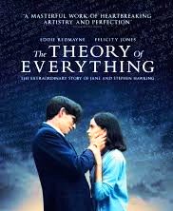

A poster from The Theory of Everything

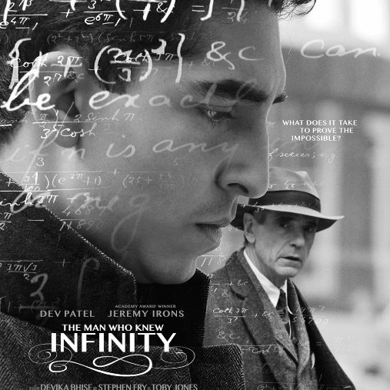

A poster from Infinity

